UNITED STATES
SECURITIES AND EXCHANGE COMMISSION
WASHINGTON, D.C. 20549

FORM 8-K

CURRENT REPORT
Pursuant to Section 13 or 15(d) of the Securities Exchange Act of 1934
Date of Report (Date of earliest event reported): August 04, 2026

SYNDAX PHARMACEUTICALS, INC.
(Exact name of Registrant as Specified in Its Charter)

Delaware |  |  | 001-37708 | 32-0162505
(State or Other Jurisdiction  of Incorporation) |  |  | (Commission File Number) | (IRS Employer  Identification No.)
730 THIRD AVENUE
FLOOR 9

NEW YORK, New York |  |  |  | 10017
(Address of Principal Executive Offices) |  |  |  | (Zip Code)

Registrant’s Telephone Number, Including Area Code: (781) 419-1400

(Former Name or Former Address, if Changed Since Last Report)

Check the appropriate box below if the Form 8-K filing is intended to simultaneously satisfy the filing obligation of the registrant under any of the following provisions:
☐Written communications pursuant to Rule 425 under the Securities Act (17 CFR 230.425)
☐Soliciting material pursuant to Rule 14a-12 under the Exchange Act (17 CFR 240.14a-12)
☐Pre-commencement communications pursuant to Rule 14d-2(b) under the Exchange Act (17 CFR 240.14d-2(b))
☐Pre-commencement communications pursuant to Rule 13e-4(c) under the Exchange Act (17 CFR 240.13e-4(c))
Securities registered pursuant to Section 12(b) of the Act:
Title of each class |  | Trading  Symbol(s) |  | Name of each exchange on which registered
Common Stock |  | SNDX |  | The Nasdaq Stock Market LLC
Indicate by check mark whether the registrant is an emerging growth company as defined in Rule 405 of the Securities Act of 1933 (§ 230.405 of this chapter) or Rule 12b-2 of the Securities Exchange Act of 1934 (§ 240.12b-2 of this chapter).
Emerging growth company ☐
If an emerging growth company, indicate by check mark if the registrant has elected not to use the extended transition period for complying with any new or revised financial accounting standards provided pursuant to Section 13(a) of the Exchange Act. ☐

Item 2.02. Results of Operations and Financial Condition.

On August 4, 2026, Syndax Pharmaceuticals, Inc. (the “Company”) issued a press release and presentation announcing its financial results for the quarter and year ended June 30, 2026. A copy of the press release and presentation are furnished as Exhibits 99.1 and 99.2 to this Current Report on Form 8-K and are incorporated herein by reference.

The information contained in this Item 2.02 and in Exhibits 99.1 and 99.2 attached hereto is intended to be furnished and shall not be deemed “filed” for purposes of Section 18 of the Securities Exchange Act of 1934, as amended (the “Exchange Act”), or otherwise subject to the liabilities of that section, nor shall it be deemed incorporated by reference into any of the Company’s filings under the Securities Act of 1933, as amended, or the Exchange Act, except as expressly set forth by specific reference in such filing.

Item 9.01. Financial Statements and Exhibits.
(d) Exhibits.

Exhibit  No. | Description
99.1 | Press Release, dated August 4, 2026
99.2 | Corporate Presentation, dated August 4, 2026
104 | Cover Page Interactive Data File (embedded within the Inline XBRL document)

SIGNATURES
Pursuant to the requirements of the Securities Exchange Act of 1934, the registrant has duly caused this report to be signed on its behalf by the undersigned hereunto duly authorized.

 | SYNDAX PHARMACEUTICALS, INC.
 | By: | /s/ Michael A. Metzger
 |  | Michael A. Metzger
 |  | Chief Executive Officer

Dated: August 4, 2026

Exhibit 99.1


Syndax Reports Second Quarter 2026 Financial Results and Provides Business Update
•
Total revenue of $73 million in 2Q26, a 92% year-over-year increase –
•
Revuforj® (revumenib) net revenue of $54.7 million in 2Q26, a 91% year-over-year increase – –
•
Niktimvo (axatilimab-csfr) net revenue of $60.3 million in 2Q26, a 67% year-over-year increase, resulting in Syndax collaboration revenue of $18.1 million –
•
Expanded pipeline with a novel, mutant-selective, allosteric EGFR inhibitor for NSCLC and an internally developed next-generation menin inhibitor for myelofibrosis–
•
Topline data expected in 4Q26 from Phase 2 trials of axatilimab in IPF and frontline cGVHD –
•
Company to host a conference call today at 4:30 p.m. ET –
NEW YORK, NY, August 4, 2026 (GLOBE NEWSWIRE) – Syndax Pharmaceuticals (Nasdaq: SNDX), a commercial-stage biopharmaceutical company advancing innovative cancer therapies, today reported its financial results for the second quarter ended June 30, 2026, and provided a business update.
“We delivered another quarter of strong commercial results, with both our medicines now annualizing at well over $200 million each and positioned for further growth,” said Michael A. Metzger, Chief Executive Officer. “Notably, we achieved $55 million in Revuforj net revenue and the sixth consecutive quarter of double-digit net revenue and prescription growth, highlighting our leadership in menin inhibition, robust demand in both NPM1 and KMT2A, and an increasing average treatment duration. Niktimvo net revenue grew to $60 million this quarter, underscoring the benefits of its unique mechanism of action in cGVHD and the substantial commercial opportunity.”

Mr. Metzger continued, “We’ve made excellent progress advancing our growing pipeline targeting multiple blockbuster opportunities, including two recently announced assets with first- and best-in-class potential in EGFR-mutated NSCLC and myelofibrosis. We are positioned to be first to frontline AML with Revuforj, driven by strong global site initiation and patient enrollment in our pivotal trials. We also have multiple near-term catalysts with Niktimvo Phase 2 data in IPF and frontline cGVHD expected in the fourth quarter, plus additional practice-informing and

potentially guideline-enabling Revuforj data in acute leukemia.”
Recent Business Highlights and Anticipated Milestones
Revuforj® (revumenib)
•
Achieved $54.7 million in Revuforj net revenue in the second quarter of 2026, a 91% increase over the second quarter of 2025 and a 12% increase over the first quarter of 2026. Total prescriptions were approximately 1,500 in the second quarter of 2026, an approximate 121% increase over the second quarter of 2025 and a 15% increase over the first quarter of 2026. The net revenue and prescription growth reflects an increasing average treatment duration, primarily driven by a growing pool of patients receiving Revuforj for an extended period in the post-transplant setting.
•
Advanced the Company’s scientific leadership in menin inhibition with the presentation of 16 revumenib abstracts at the 2026 American Society of Clinical Oncology (ASCO) and the European Hematology Association (EHA) annual meetings in June 2026. The data presented span multiple acute leukemia subtypes and settings, including frontline and post-transplant maintenance.
•
Published data from the Phase 1/2 SAVE trial of an all-oral combination of revumenib, decitabine/cedazuridine, and venetoclax in relapsed/refractory (R/R) NPM1-mutated (NPM1m), KMT2A-rearranged (KMT2Ar), and NUP98-rearranged (NUP98r) acute myeloid leukemia (AML) in the Journal of Clinical Oncology in June 2026. The results showed deep and durable remissions in a heavily pretreated patient population. The ORR was 88% (37/42), CRc was 71% (30/42), and CR/CRh was 60% (25/42). 80% of evaluable CRc responders were measurable residual disease (MRD) negative. 45% (19/42) of patients proceeded to a transplant and 63% (12/19) resumed revumenib post-transplant.
•
Published preclinical revumenib data showing that menin is a novel dependency in proliferative megakaryocytes, major drivers of myelofibrosis (MF), in Cancer Cell in July 2026. These data provide the basis for the Company’s plans to develop SNDX-62122, an internally developed, next-generation menin inhibitor, for MF.
•
The Company expects to have a major presence at upcoming medical meetings in the second half of 2026 with the presentation of new/updated revumenib data including:
•
Real-world evidence from multiple centers
•
Post-transplant maintenance data

•
Frontline data from the BEAT AML trial of revumenib in combination with venetoclax/azacitidine in NPM1m and KMT2Ar AML
•
Frontline data from the Phase 1/2 SAVE trial of an all-oral combination of revumenib, decitabine/cedazuridine, and venetoclax in NPM1m, KMT2Ar, or NUP98r AML
•
Frontline data from the Phase 1 trial of revumenib in combination with intensive chemotherapy in NPM1m, KMT2Ar, or NUP98r AML
•
Multiple clinical trials evaluating revumenib across the acute leukemia treatment continuum are ongoing, such as:
•
EVOLVE-2: A pivotal, Phase 3, randomized, double-blind, placebo-controlled trial of revumenib in combination with venetoclax and azacitidine in newly diagnosed NPM1m (primary efficacy analysis population) and KMT2Ar AML patients who are unfit for intensive chemotherapy. The trial is being conducted in collaboration with the HOVON network, a leading cooperative clinical trial group with extensive experience studying novel therapies for hematologic malignancies.
•
REVEAL-ND: A pivotal, Phase 3, randomized, double-blind, placebo-controlled trial of revumenib in combination with intensive chemotherapy in newly diagnosed NPM1m AML patients.
•
SAVE: A Phase 1/2 trial evaluating an all-oral combination of revumenib with venetoclax and decitabine/cedazuridine in pediatric and adult patients with newly diagnosed and R/R AML or mixed-lineage acute leukemia harboring either NPM1m, KMT2Ar, or NUP98r alterations. The trial is being conducted by investigators from MD Anderson Cancer Center.
•
Intensive chemotherapy: Two ongoing Phase 1 trials evaluating the combination of revumenib with intensive chemotherapy (7+3) in newly diagnosed NPM1m or KMT2Ar acute leukemia patients.
•
BEAT AML: A Phase 1 trial evaluating the combination of revumenib with venetoclax and azacitidine in newly diagnosed older adults (≥60 years) with NPM1m or KMT2Ar AML. The trial is being conducted as part of the Leukemia & Lymphoma Society's Beat AML® Master Clinical Trial.
•
Post-transplant maintenance: A Phase 1 trial evaluating the safety and preliminary efficacy of revumenib as post-transplant maintenance in patients with KMT2Ar or

NPM1m acute leukemia. The trial is being conducted by investigators from the City of Hope Medical Center.
•
Break Through Cancer: A Phase 2 trial studying whether the combination of revumenib and venetoclax can eliminate MRD in patients with AML and extend progression-free survival. The trial is being conducted by Break Through Cancer, a collaboration between leading U.S. cancer research centers.
•
INTERCEPT: A Phase 1 trial evaluating the use of novel therapies, including revumenib, to target MRD and early relapse in AML. The trial is being conducted by the Australasian Leukaemia and Lymphoma Group as part of the INTERCEPT AML master clinical trial.
•
The Company expects the RAVEN trial to initiate in the second half of 2026. RAVEN is a Phase 2 collaborative trial of revumenib in combination with venetoclax and azacitidine in newly diagnosed KMT2Ar patients who would be considered eligible, or fit, for intensive chemotherapy.
•
The Company expects the MenTain Phase 2 trial to initiate around the end of 2026. MenTain will be the first randomized, placebo-controlled trial specifically focused on evaluating revumenib as post-transplant maintenance.
•
The Company expects to publish safety and efficacy data from R/R NUP98r acute leukemia patients treated with revumenib in the fourth quarter of 2026.
Niktimvo (axatilimab-csfr)
•
Achieved $60.3 million in Niktimvo net revenue in the second quarter of 2026, a 67% increase over the second quarter of 2025 and a 9% increase over the first quarter of 2026. Syndax and Incyte are co-commercializing Niktimvo. Syndax records 50% of the Niktimvo net commercial profit, defined as net product revenue minus the cost of sales and commercial expenses. Syndax’s share of the Niktimvo product contribution, reported as collaboration revenue, was $18.1 million in the second quarter of 2026.
•
Two trials evaluating axatilimab in combination with standard of care therapies in newly diagnosed chronic graft-versus-host disease (cGVHD) patients are ongoing, including:
o
A Phase 2, open-label, randomized, multicenter trial of axatilimab in combination with ruxolitinib in patients ≥ 12 years of age with newly diagnosed cGVHD. Topline data are anticipated in the fourth quarter of 2026.

o
A pivotal Phase 3, randomized, double-blind, placebo-controlled, multicenter trial of axatilimab in combination with corticosteroids in patients ≥ 12 years of age with newly diagnosed cGVHD. Topline data are anticipated in early 2028.
•
The Company anticipates topline data from MAXPIRe, a Phase 2, 26-week randomized, double-blinded, placebo-controlled trial of axatilimab on top of standard of care in patients with idiopathic pulmonary fibrosis in the fourth quarter of 2026.
Pipeline Assets

SNDX-4321
•
In July 2026, the Company announced the expansion of its pipeline with SNDX-4321, a mutant-selective, CNS-penetrant, allosteric EGFR inhibitor. SNDX-4321 is in development for non-small cell lung cancer (NSCLC) patient populations with significant unmet needs, such as those with L858R mutations, CNS metastases, atypical activating mutations, or acquired resistance to current therapies. In contrast to ATP-site directed third and fourth generation EGFR inhibitors, SNDX-4321 is a novel allosteric inhibitor which binds at a pocket adjacent to the ATP site that is only accessible in the presence of L858R and certain other EGFR mutations.
•
The Company expects to submit an investigational new drug (IND) application for SNDX-4321 by the end of 2026 and to initiate a Phase 1 trial in EGFRm NSCLC in 2027.
SNDX-62122
•
In July 2026, the Company announced the selection of SNDX-62122, a next-generation menin inhibitor, for development in MF. SNDX-62122 is the first candidate from a library of internally developed, wholly owned next-generation menin inhibitors that the Company intends to advance into new areas.
•
The Company expects to submit an IND and initiate a Phase 1 trial of SNDX-62122 in MF in 2027. The development of SNDX-62122 will be informed by a Phase 1/2 proof-of-principle trial of revumenib in MF that is expected to initiate in the fourth quarter of 2026 with initial clinical data expected in the second half of 2027.
Second Quarter 2026 Financial Results
As of June 30, 2026, Syndax had cash, cash equivalents, and short- and long-term investments of $575.1 million and 89.4 million common shares and prefunded warrants outstanding.

Total revenue for the second quarter of 2026 was $72.8 million, which consisted of $54.7 million in Revuforj net revenue and $18.1 million in Niktimvo collaboration revenue. The Niktimvo collaboration revenue is derived from the $60.3 million in Niktimvo net revenue that was previously

reported by the Company's partner Incyte for the second quarter 2026. Syndax records 50% of the Niktimvo net commercial profit, defined as net revenue (recorded by Incyte) minus the cost of sales and commercial expenses.

Second quarter 2026 research and development expenses increased to $68.0 million from $62.2 million for the comparable prior year period. The year-over-year change was primarily the result of increased expenses associated with frontline trials evaluating revumenib in combination with standard-of-care agents in the treatment of AML.

Second quarter 2026 selling, general and administrative expenses decreased to $41.5 million from $43.8 million for the comparable prior year period. The year-over-year change was primarily the result of decreased commercial expenses due to launch costs incurred in the second quarter of 2025 for Revuforj and Niktimvo that were not incurred in the same period in 2026.

For the six months ended June 30, 2026, Syndax reported a net loss attributable to common stockholders of $49.4 million, or $0.55 per share, compared to a net loss attributable to common stockholders of $71.8 million, or $0.83 per share, for the comparable prior year period.

Financial Guidance
For the full year of 2026, the Company continues to expect total research and development plus selling, general and administrative expenses to be approximately $400 million, excluding the impact of $50 million in estimated non-cash stock compensation expense.
Syndax expects that its cash, cash equivalents and short-term investments, combined with its anticipated product revenue, collaboration revenue and interest income, will enable the Company to reach profitability.
Conference Call and Webcast
In connection with the earnings release, Syndax's management team will host a conference call and live audio webcast at 4:30 p.m. ET today, August 4, 2026.
The live audio webcast and accompanying slides may be accessed through the Events & Presentations page in the Investors section of the Company's website. Alternatively, the conference call may be accessed through the following:
Conference ID: Syndax2Q26
Domestic Dial-in Number: 800-590-8290
International Dial-in Number: 240-690-8800
Live webcast: https://sndx-2q26.open-exchange.net/

For those unable to participate in the conference call or webcast, a replay will be available on the Investors section of the Company's website at www.syndax.com approximately 24 hours after the conference call and will be available for 90 days following the call.
About Revuforj® (revumenib)
Revuforj (revumenib) is the first and only menin inhibitor that is FDA approved for the treatment of adult and pediatric patients one year and older with relapsed or refractory (R/R) acute myeloid leukemia (AML) with a susceptible NPM1 mutation who have no satisfactory alternative treatment options or R/R acute leukemia with a KMT2A translocation as determined by an FDA-authorized test.
Multiple trials of revumenib are ongoing or planned across the treatment landscape, including in combination with standard of care therapies in newly diagnosed patients with NPM1m or KMT2Ar AML.
About Niktimvo (axatilimab-csfr)
Niktimvo (axatilimab-csfr) is a first-in-class colony stimulating factor-1 receptor (CSF-1R)-blocking antibody approved for use in the U.S. for the treatment of chronic graft-versus-host disease (GVHD) after failure of at least two prior lines of systemic therapy in adult and pediatric patients weighing at least 40 kg (88.2 lbs).
In 2016, Syndax licensed exclusive worldwide rights to develop and commercialize axatilimab from UCB. In September 2021, Syndax and Incyte entered into an exclusive worldwide co-development and co-commercialization license agreement for axatilimab in chronic GVHD and any future indications.
Axatilimab is being studied in frontline combination trials in chronic GVHD, including a Phase 2 combination trial with ruxolitinib (NCT06388564) and a Phase 3 combination trial with steroids (NCT06585774). Axatilimab is also being studied in an ongoing Phase 2 trial in patients with idiopathic pulmonary fibrosis (NCT06132256).
About Syndax
Syndax Pharmaceuticals is a commercial-stage biopharmaceutical company advancing innovative cancer therapies. Highlights of the Company's pipeline include Revuforj® (revumenib), an FDA-approved menin inhibitor, and Niktimvo (axatilimab-csfr), an FDA-approved monoclonal antibody that blocks the colony stimulating factor 1 (CSF-1) receptor. Fueled by our commitment to reimagining cancer care, Syndax is working to unlock the full potential of its pipeline and is

conducting several clinical trials across the continuum of treatment. For more information, please visit www.syndax.com/ or follow the Company on X and LinkedIn.
Forward-Looking Statements
This press release contains forward-looking statements within the meaning of the Private Securities Litigation Reform Act of 1995. Words such as "anticipate," "believe," "could," "estimate," "expects," "intend," "may," "plan," "potential," "predict," "project," "should," "will," "would" or the negative or plural of those terms, and similar expressions (as well as other words or expressions referencing future events, conditions or circumstances) are intended to identify forward-looking statements. These forward-looking statements are based on Syndax's expectations and assumptions as of the date of this press release. Each of these forward-looking statements involves risks and uncertainties. Actual results may differ materially from these forward-looking statements. Forward-looking statements contained in this press release include, but are not limited to, statements about the progress, timing, clinical development and scope of clinical trials, the reporting of clinical data for Syndax's product candidates, the acceptance of Syndax and its partners' products in the marketplace, sales, marketing, manufacturing and distribution requirements, the potential use of its product candidates to treat various cancer indications and fibrotic diseases, Syndax's expected full year total operating expenses, including its estimated non-cash stock compensation expense, and Syndax’s expectation that its cash, cash equivalents and short-term investments, combined with its anticipated product revenue, collaboration revenue and interest income, will enable the Company to reach profitability. Many factors may cause differences between current expectations and actual results, including: unexpected safety or efficacy data observed during preclinical or clinical trials; clinical trial site activation or enrollment rates that are lower than expected; changes to Revuforj's or Niktimvo’s commercial availability; changes in expected or existing competition; changes in the regulatory environment; failure of Syndax's collaborators to support or advance collaborations or product candidates; and unexpected litigation or other disputes. Other factors that may cause Syndax's actual results to differ from those expressed or implied in the forward-looking statements in this press release are discussed in Syndax's filings with the U.S. Securities and Exchange Commission, including the "Risk Factors" sections contained therein. Except as required by law, Syndax assumes no obligation to update any forward-looking statements contained herein to reflect any change in expectations, even as new information becomes available.
Niktimvo is a trademark of Incyte.
All other trademarks are the property of their respective owners.
Syndax Contact

Sharon Klahre
Syndax Pharmaceuticals, Inc.
sklahre@syndax.com
Tel 781.684.9827
SNDX-G

SYNDAX PHARMACEUTICALS, INC.
(unaudited)
CONDENSED CONSOLIDATED BALANCE SHEETS
 |  |  | June 30, |  |  |  | December 31,
(In thousands) |  |  | 2026 |  |  |  | 2025
Cash, cash equivalents, short and long-term investments |  |  | $ | 575,077 |  |  | $ | 394,070
Total assets |  |  | $ | 703,652 |  |  | $ | 529,706
Total liabilities |  |  | $ | 688,553 |  |  | $ | 465,076
Total stockholders' equity |  |  | $ | 15,099 |  |  | $ | 64,630
Common stock outstanding |  |  |  | 89,150,619 |  |  |  | 87,405,979
Common stock and common stock equivalents* |  |  |  | 116,271,946 |  |  |  | 103,437,561
*Common stock and common stock equivalents:
 | Common stock |  |  | 89,150,619 |  |  |  | 87,405,979
 | Common stock warrants (pre-funded) |  |  | 285,714 |  |  |  | 285,714
 |  | Common stock and pre-funded stock warrants |  | 89,436,333 |  |  |  | 87,691,693
 | Options to purchase common stock |  |  | 13,389,854 |  |  |  | 13,128,306
 | Restricted Stock Units |  |  | 3,348,409 |  |  |  | 2,617,562
 | Conversion of convertible notes |  |  | 10,097,350 |  |  |  | -
 |  | Total common stock and common stock equivalents |  | 116,271,946 |  |  |  | 103,437,561

SYNDAX PHARMACEUTICALS, INC.
(unaudited)
CONDENSED CONSOLIDATED STATEMENTS OF OPERATIONS
 |  |  | Three Months Ended June 30, |  |  |  |  |  |  |  | Six Months Ended June 30,
(In thousands, except share and per share data) |  |  | 2026 |  |  |  | 2025 |  |  |  | 2026 |  |  |  | 2025
Revenue
 | Product revenue, net |  | $ | 54,700 |  |  |  | 28,600 |  |  | $ | 103,623 |  |  |  | 48,642
 | Collaboration revenue, net |  |  | 18,088 |  |  |  | 9,358 |  |  |  | 34,029 |  |  |  | 9,111
Total revenues |  |  |  | 72,788 |  |  |  | 37,958 |  |  |  | 137,652 |  |  |  | 57,753
Operating expenses:
 | Cost of product sales |  | $ | 3,208 |  |  |  | 1,279 |  |  | $ | 5,841 |  |  |  | 2,164
 | Research and development |  |  | 68,036 |  |  |  | 62,227 |  |  |  | 126,881 |  |  |  | 123,863
 | Selling, general and administrative |  |  | 41,539 |  |  |  | 43,805 |  |  |  | 79,127 |  |  |  | 84,836
Total operating expenses |  |  |  | 112,783 |  |  |  | 107,311 |  |  |  | 211,849 |  |  |  | 210,863
Loss from operations |  |  |  | (39,995 | ) |  |  | (69,353 | ) |  |  | (74,197 | ) |  |  | (153,110 | )
Other (expense) income, net:
 | Royalty interest expense |  |  | (12,119 | ) |  |  | (7,854 | ) |  |  | (23,965 | ) |  |  | (15,903 | )
 | Convertible note interest expense |  |  | (555 | ) |  |  | - |  |  |  | (555 | ) |  |  | -
 | Other interest expense |  |  | (2 | ) |  |  | (4 | ) |  |  | (2 | ) |  |  | (6 | )
 | Interest income |  |  | 3,746 |  |  |  | 5,950 |  |  |  | 7,307 |  |  |  | 13,133
 | Other expense |  |  | (438 | ) |  |  | (586 | ) |  |  | (624 | ) |  |  | (807 | )
Total other (expense) income, net |  |  |  | (9,368 | ) |  |  | (2,494 | ) |  |  | (17,839 | ) |  |  | (3,583 | )
Net loss |  |  | $ | (49,363 | ) |  | $ | (71,847 | ) |  | $ | (92,036 | ) |  | $ | (156,693 | )
Other comprehensive loss:
 | Unrealized (loss) gain on marketable securities |  |  | (151 | ) |  |  | (242 | ) |  |  | (592 | ) |  |  | 122
Other comprehensive loss |  |  |  | (49,514 | ) |  |  | (72,089 | ) |  |  | (92,628 | ) |  |  | (156,571 | )
Net loss per share:
Basic and diluted loss per share attributable to common stockholders |  |  | $ | (0.55 | ) |  | $ | (0.83 | ) |  | $ | (1.04 | ) |  | $ | (1.82 | )
Weighted-average common shares used in calculating:
Basic and diluted loss per share attributable to common stockholders |  |  |  | 88,991,317 |  |  |  | 86,337,237 |  |  |  | 88,625,508 |  |  |  | 86,255,020


Second Quarter 2026 Financial Results and Business Update August 4, 2026 Exhibit 99.2

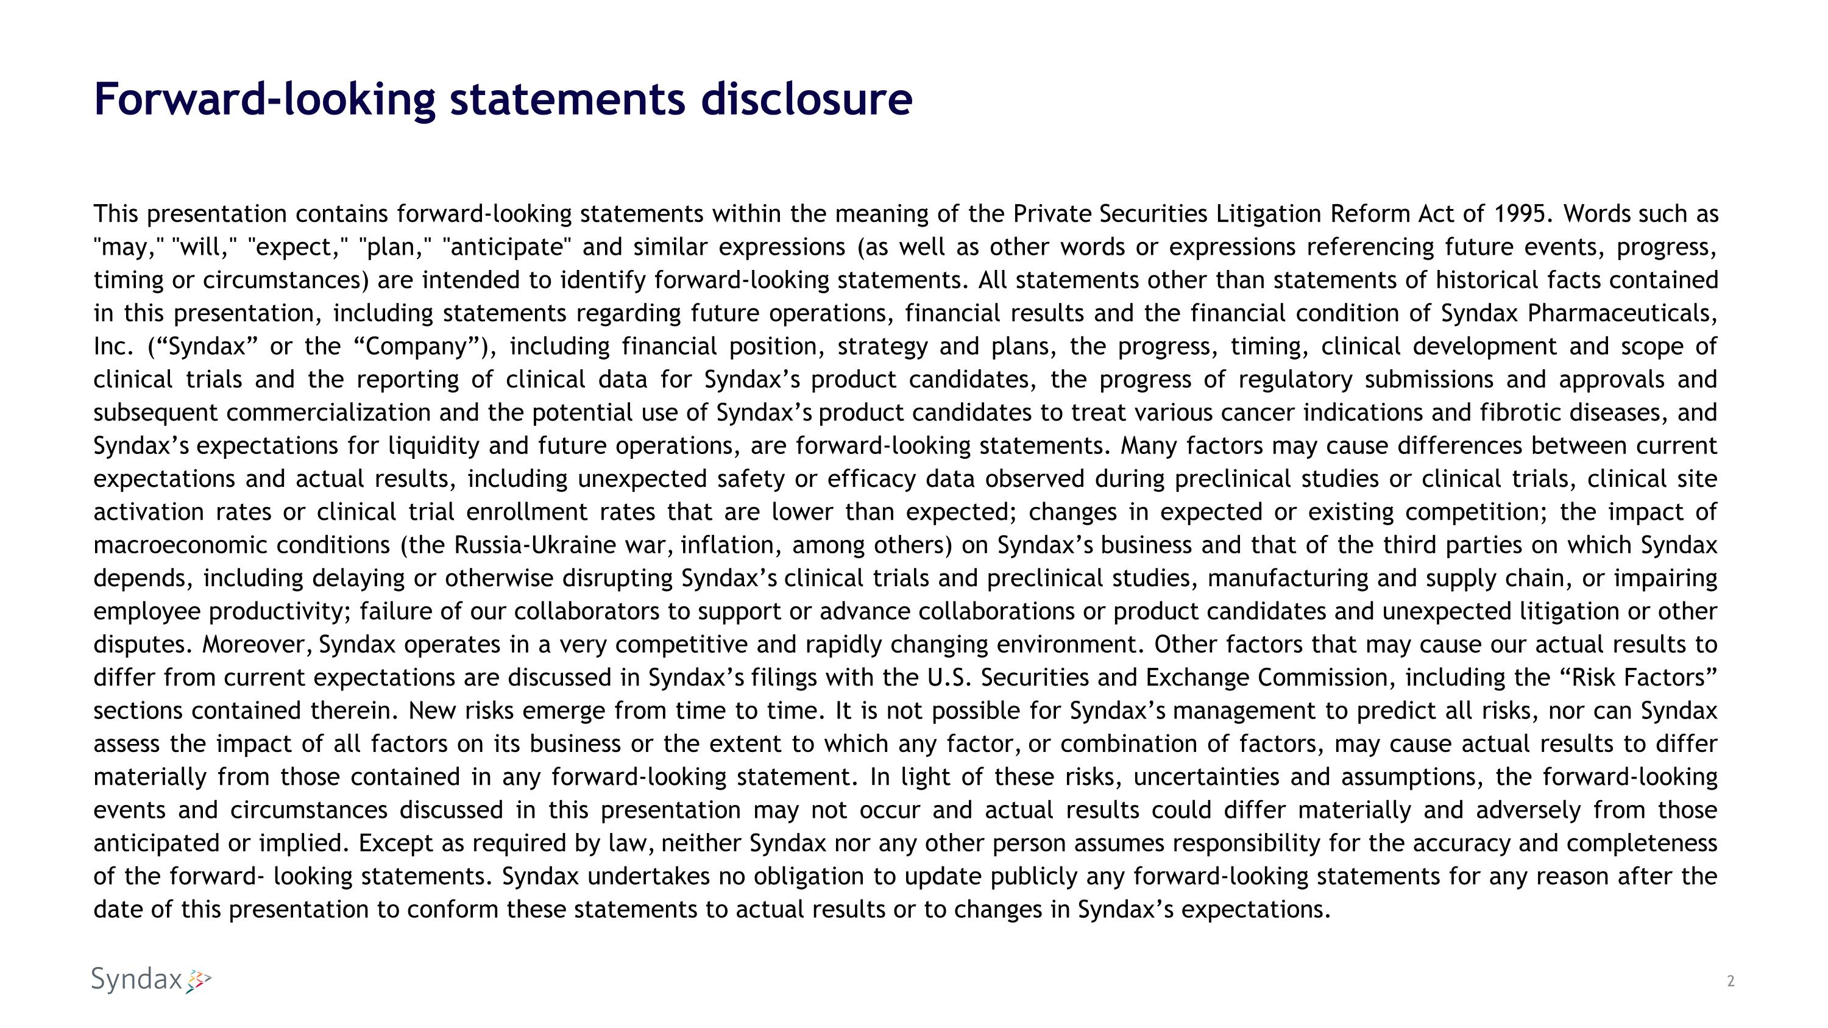
Forward-looking statements disclosure This presentation contains forward-looking statements within the meaning of the Private Securities Litigation Reform Act of 1995. Words such as "may," "will," "expect," "plan," "anticipate" and similar expressions (as well as other words or expressions referencing future events, progress, timing or circumstances) are intended to identify forward-looking statements. All statements other than statements of historical facts contained in this presentation, including statements regarding future operations, financial results and the financial condition of Syndax Pharmaceuticals, Inc. (“Syndax” or the “Company”), including financial position, strategy and plans, the progress, timing, clinical development and scope of clinical trials and the reporting of clinical data for Syndax’s product candidates, the progress of regulatory submissions and approvals and subsequent commercialization and the potential use of Syndax’s product candidates to treat various cancer indications and fibrotic diseases, and Syndax’s expectations for liquidity and future operations, are forward-looking statements. Many factors may cause differences between current expectations and actual results, including unexpected safety or efficacy data observed during preclinical studies or clinical trials, clinical site activation rates or clinical trial enrollment rates that are lower than expected; changes in expected or existing competition; the impact of macroeconomic conditions (the Russia-Ukraine war, inflation, among others) on Syndax’s business and that of the third parties on which Syndax depends, including delaying or otherwise disrupting Syndax’s clinical trials and preclinical studies, manufacturing and supply chain, or impairing employee productivity; failure of our collaborators to support or advance collaborations or product candidates and unexpected litigation or other disputes. Moreover, Syndax operates in a very competitive and rapidly changing environment. Other factors that may cause our actual results to differ from current expectations are discussed in Syndax’s filings with the U.S. Securities and Exchange Commission, including the “Risk Factors” sections contained therein. New risks emerge from time to time. It is not possible for Syndax’s management to predict all risks, nor can Syndax assess the impact of all factors on its business or the extent to which any factor, or combination of factors, may cause actual results to differ materially from those contained in any forward-looking statement. In light of these risks, uncertainties and assumptions, the forward-looking events and circumstances discussed in this presentation may not occur and actual results could differ materially and adversely from those anticipated or implied. Except as required by law, neither Syndax nor any other person assumes responsibility for the accuracy and completeness of the forward- looking statements. Syndax undertakes no obligation to update publicly any forward-looking statements for any reason after the date of this presentation to conform these statements to actual results or to changes in Syndax’s expectations.

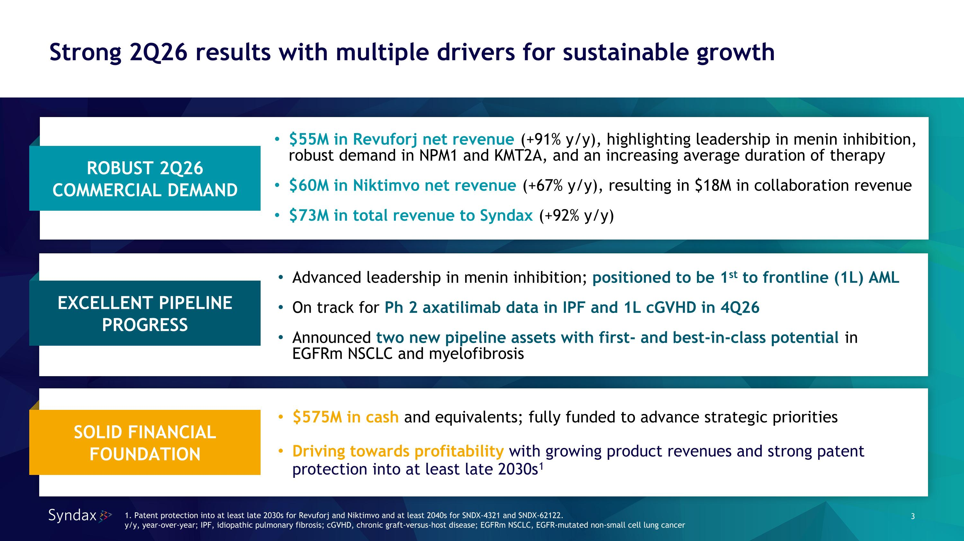
Strong 2Q26 results with multiple drivers for sustainable growth 1. Patent protection into at least late 2030s for Revuforj and Niktimvo and at least 2040s for SNDX-4321 and SNDX-62122. y/y, year-over-year; IPF, idiopathic pulmonary fibrosis; cGVHD, chronic graft-versus-host disease; EGFRm NSCLC, EGFR-mutated non-small cell lung cancer $575M in cash and equivalents; fully funded to advance strategic priorities Driving towards profitability with growing product revenues and strong patent protection into at least late 2030s1 Advanced leadership in menin inhibition; positioned to be 1st to frontline (1L) AML On track for Ph 2 axatilimab data in IPF and 1L cGVHD in 4Q26 Announced two new pipeline assets with first- and best-in-class potential in EGFRm NSCLC and myelofibrosis $55M in Revuforj net revenue (+91% y/y), highlighting leadership in menin inhibition, robust demand in NPM1 and KMT2A, and an increasing average duration of therapy $60M in Niktimvo net revenue (+67% y/y), resulting in $18M in collaboration revenue $73M in total revenue to Syndax (+92% y/y) ROBUST 2Q26 COMMERCIAL DEMAND EXCELLENT PIPELINE PROGRESS SOLID FINANCIAL FOUNDATION

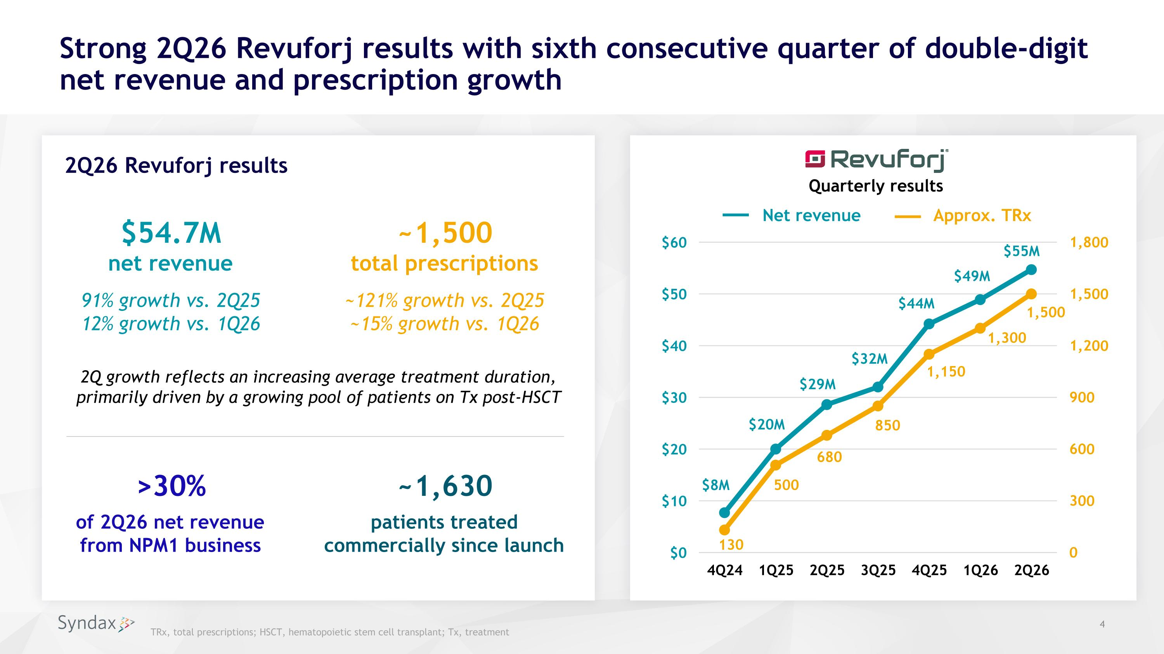
Strong 2Q26 Revuforj results with sixth consecutive quarter of double-digit net revenue and prescription growth TRx, total prescriptions; HSCT, hematopoietic stem cell transplant; Tx, treatment ~1,630 patients treated commercially since launch 2Q26 Revuforj results $54.7M ?net revenue >30% of 2Q26 net revenue?from NPM1 business ~1,500?total prescriptions ~121% growth vs. 2Q25?~15% growth vs. 1Q26 91% growth vs. 2Q25?12% growth vs. 1Q26 $49M $55M $44M $32M $29M $8M $20M 1,500 1,300 1,150 850 680 500 130 Net revenue Approx. TRx 2Q growth reflects an increasing average treatment duration, primarily driven by a growing pool of patients on Tx post-HSCT Quarterly results

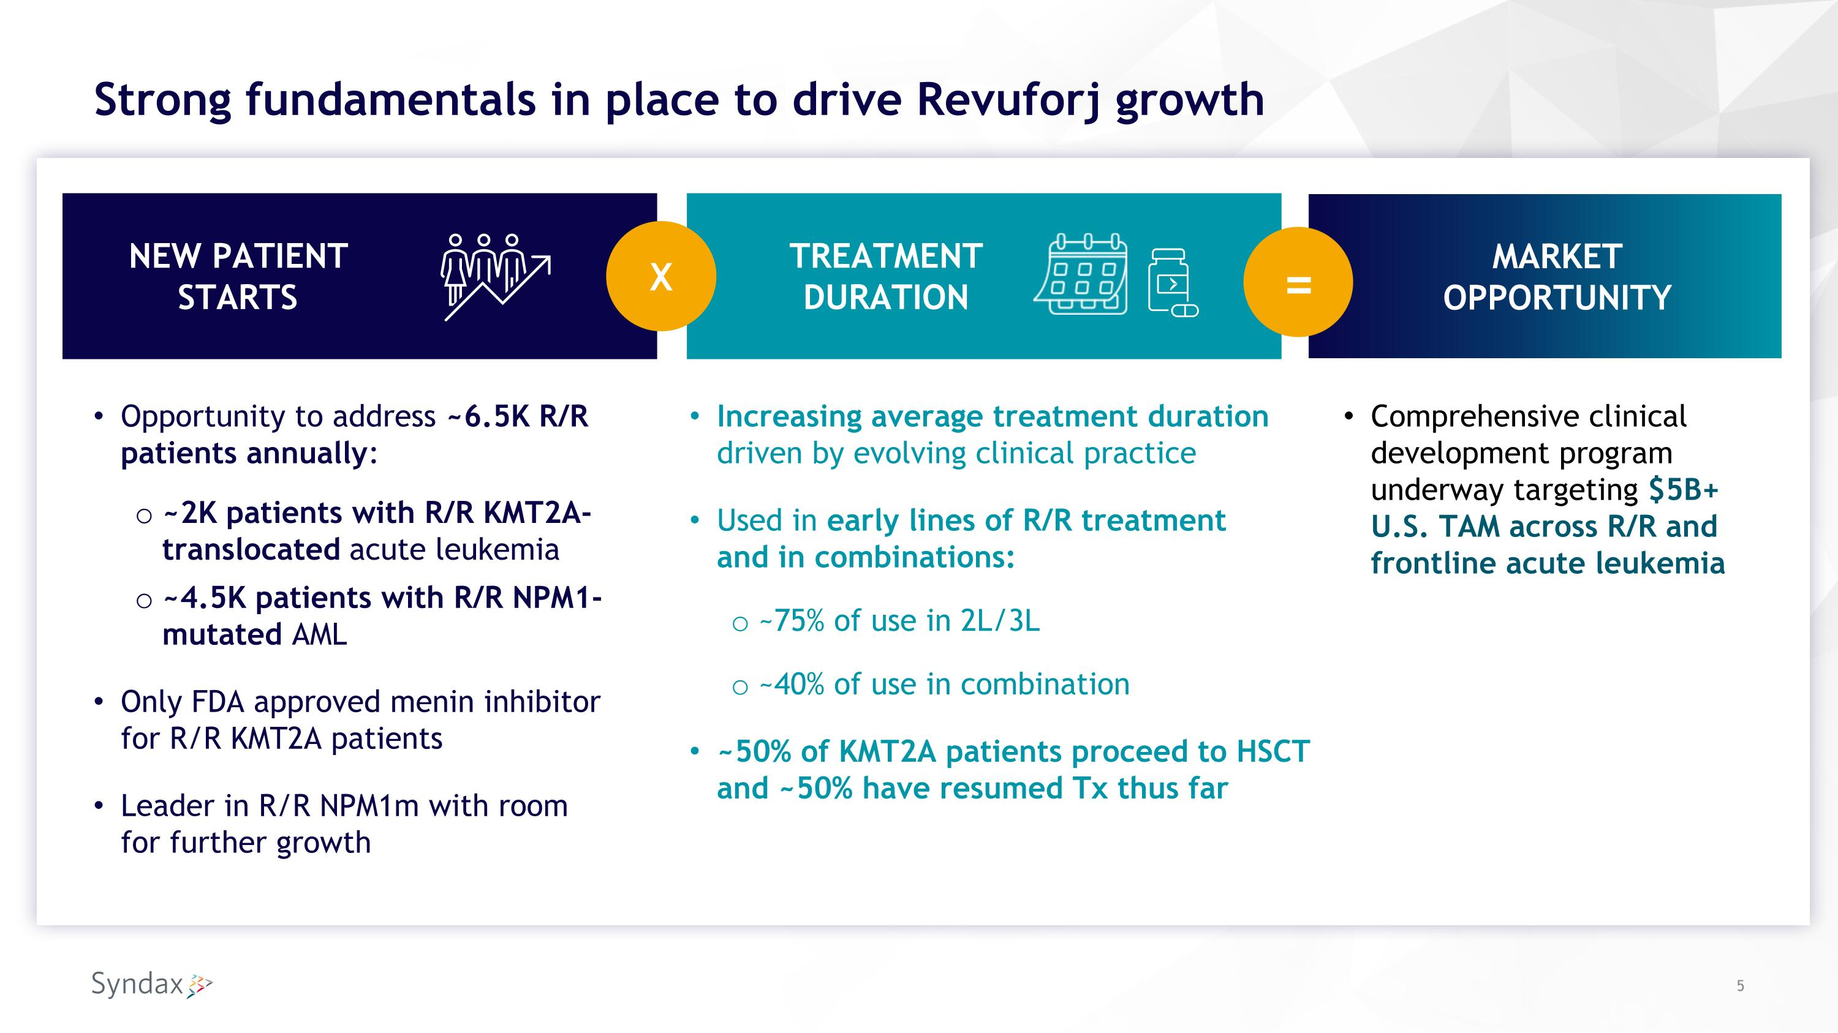
Strong fundamentals in place to drive Revuforj growth Increasing average treatment duration driven by evolving clinical practice Used in early lines of R/R treatment?and in combinations: ~75% of use in 2L/3L ~40% of use in combination ~50% of KMT2A patients proceed to HSCT and ~50% have resumed Tx thus far Opportunity to address ~6.5K R/R patients annually: ~2K patients with R/R KMT2A-translocated acute leukemia ~4.5K patients with R/R NPM1-mutated AML Only FDA approved menin inhibitor for R/R KMT2A patients Leader in R/R NPM1m with room for further growth X = TREATMENT DURATION NEW PATIENT STARTS Comprehensive clinical development program underway targeting $5B+ U.S. TAM across R/R and frontline acute leukemia MARKET OPPORTUNITY

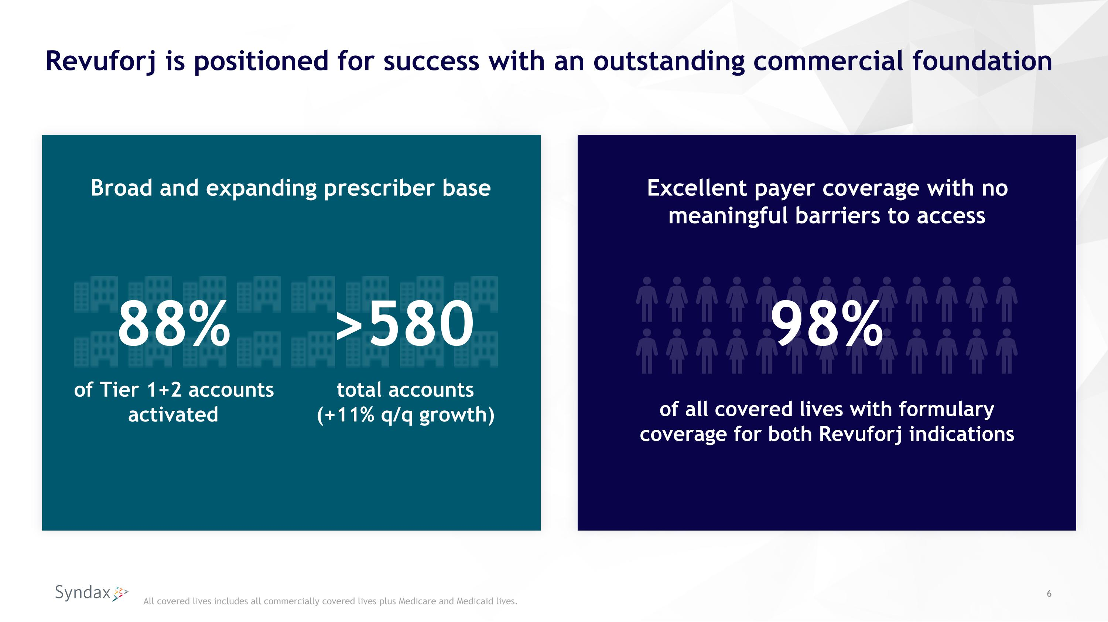
Revuforj is positioned for success with an outstanding commercial foundation All covered lives includes all commercially covered lives plus Medicare and Medicaid lives. Excellent payer coverage with no meaningful barriers to access of all covered lives with formulary coverage for both Revuforj indications 98% Broad and expanding prescriber base of Tier 1+2 accounts activated 88% total accounts?(+11% q/q growth) >580

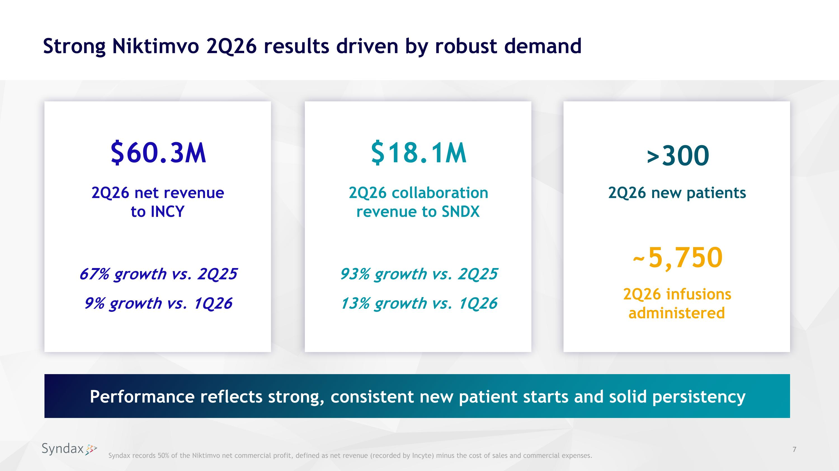
Strong Niktimvo 2Q26 results driven by robust demand >300 2Q26 new patients ~5,750 2Q26 infusions administered Syndax records 50% of the Niktimvo net commercial profit, defined as net revenue (recorded by Incyte) minus the cost of sales and commercial expenses. $60.3M 2Q26 net revenue?to INCY 67% growth vs. 2Q25 9% growth vs. 1Q26 $18.1M 2Q26 collaboration revenue to SNDX 93% growth vs. 2Q25 13% growth vs. 1Q26 Performance reflects strong, consistent new patient starts and solid persistency

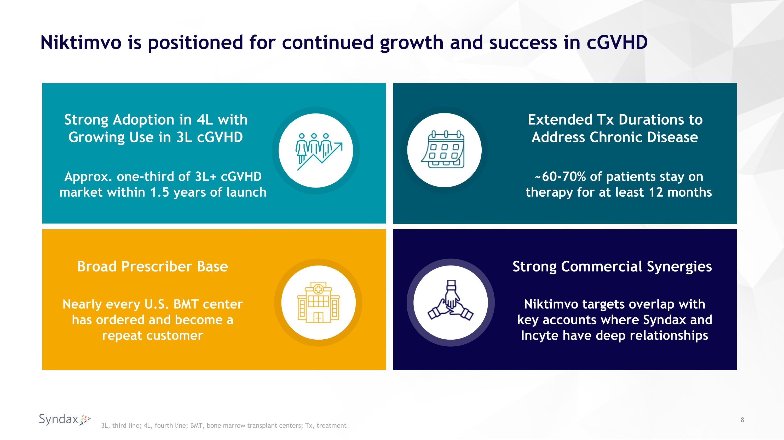
Niktimvo is positioned for continued growth and success in cGVHD Extended Tx Durations to Address Chronic Disease Broad Prescriber Base Strong Adoption in 4L with Growing Use in 3L cGVHD ~60-70% of patients stay on therapy for at least 12 months Strong Commercial Synergies Approx. one-third of 3L+ cGVHD market within 1.5 years of launch Nearly every U.S. BMT center has ordered and become a repeat customer Niktimvo targets overlap with key accounts where Syndax and Incyte have deep relationships 3L, third line; 4L, fourth line; BMT, bone marrow transplant centers; Tx, treatment

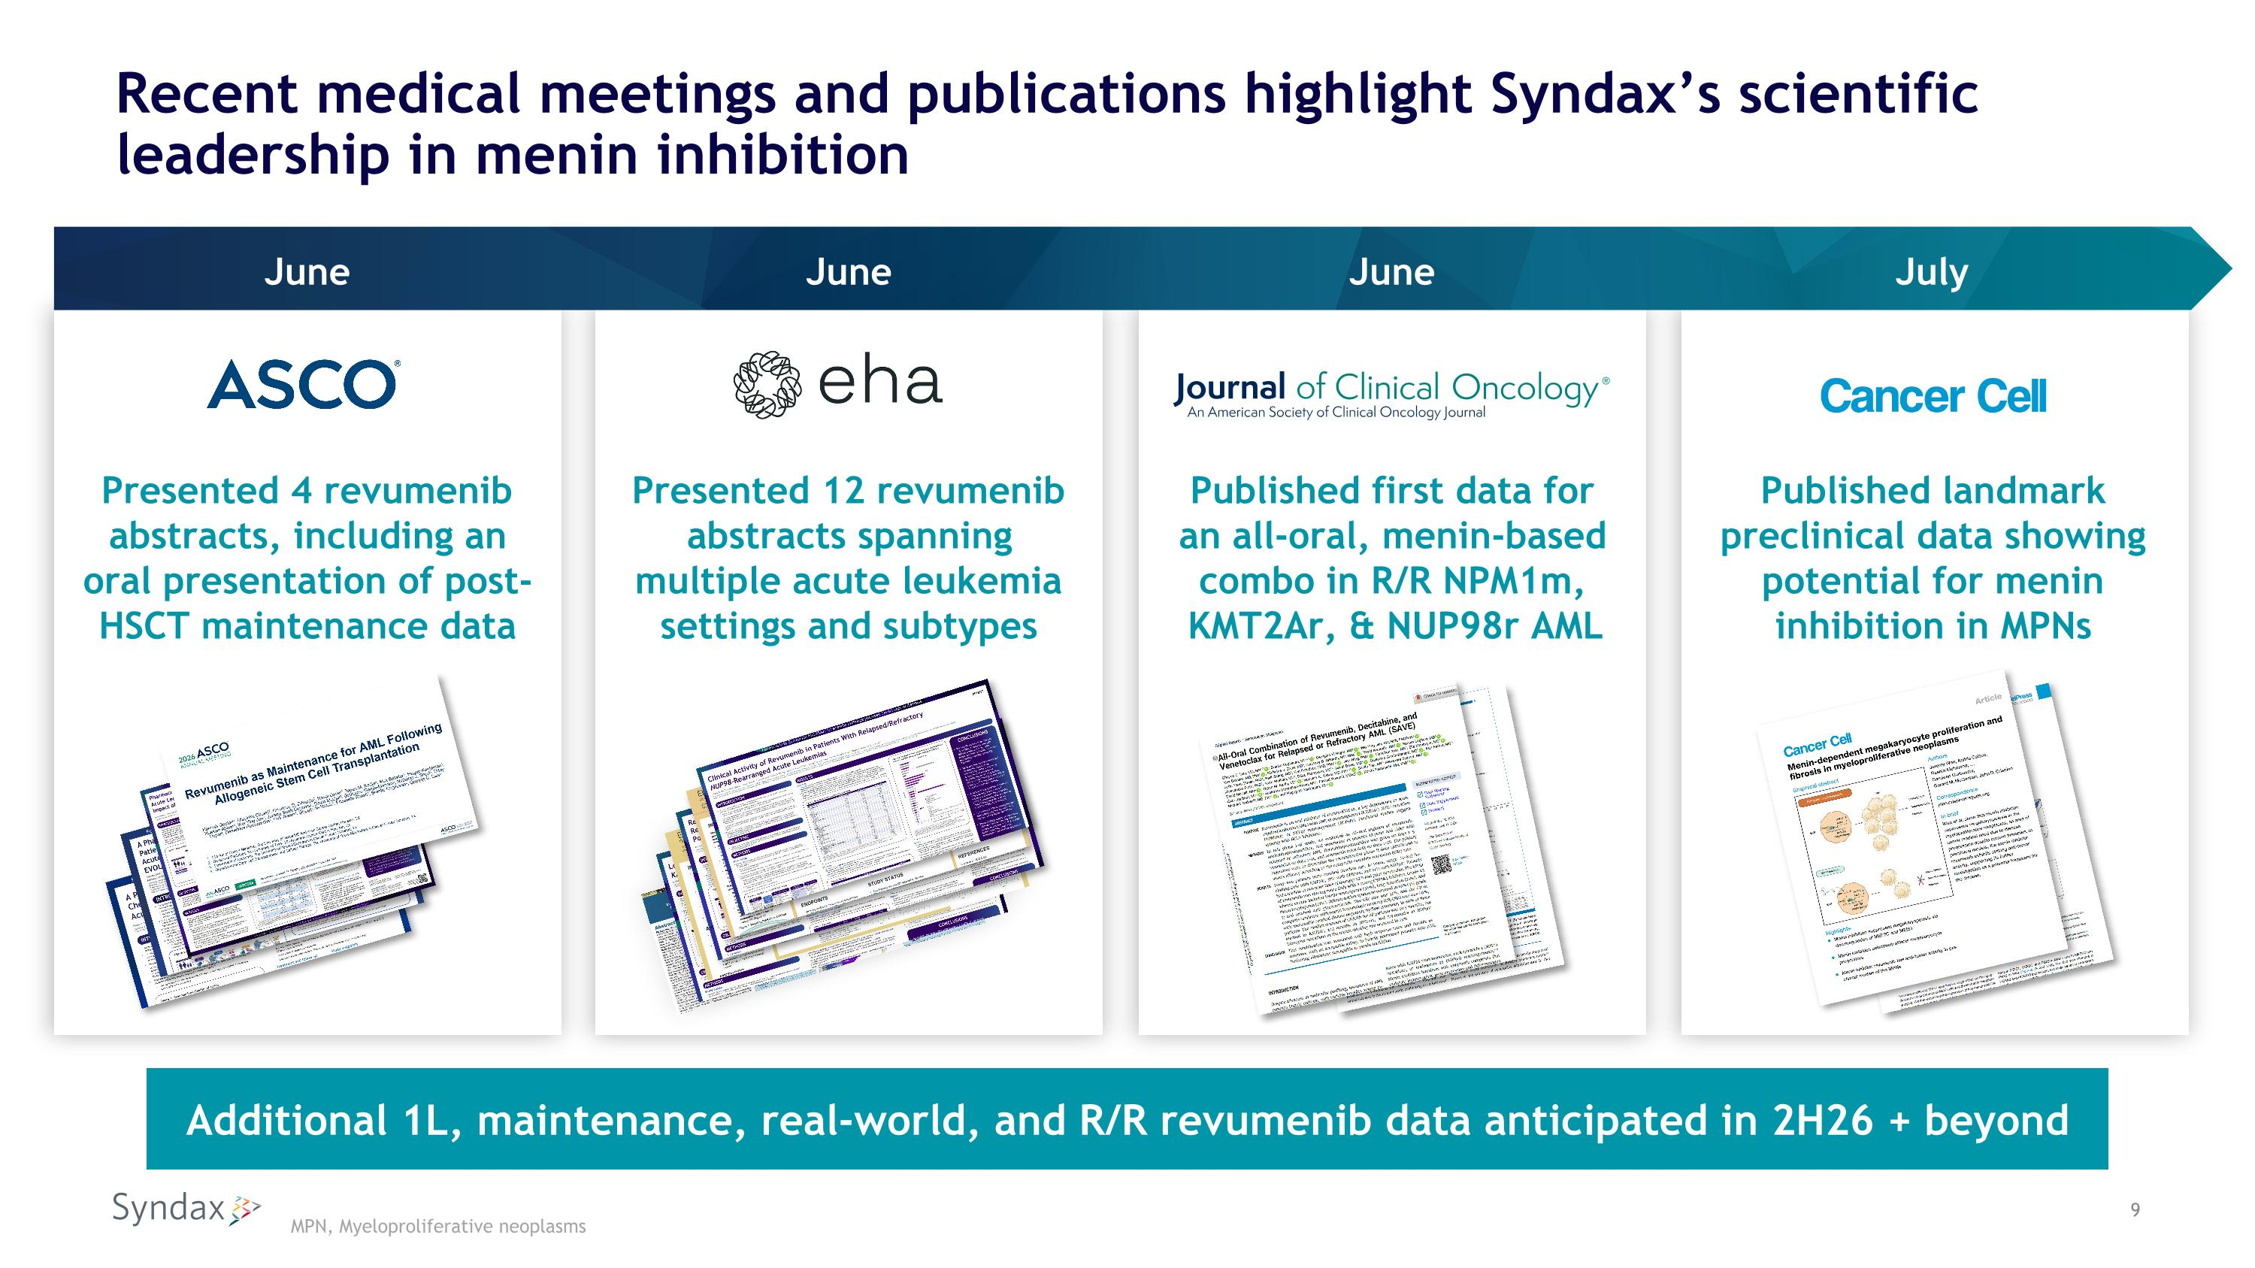
Recent medical meetings and publications highlight Syndax’s scientific leadership in menin inhibition Presented 4 revumenib abstracts, including an oral presentation of post-HSCT maintenance data Presented 12 revumenib abstracts spanning multiple acute leukemia settings and subtypes Published first data for an all-oral, menin-based combo in R/R NPM1m, KMT2Ar, & NUP98r AML Published landmark preclinical data showing potential for menin inhibition in MPNs July June June June Additional 1L, maintenance, real-world, and R/R revumenib data anticipated in 2H26 + beyond MPN, Myeloproliferative neoplasms

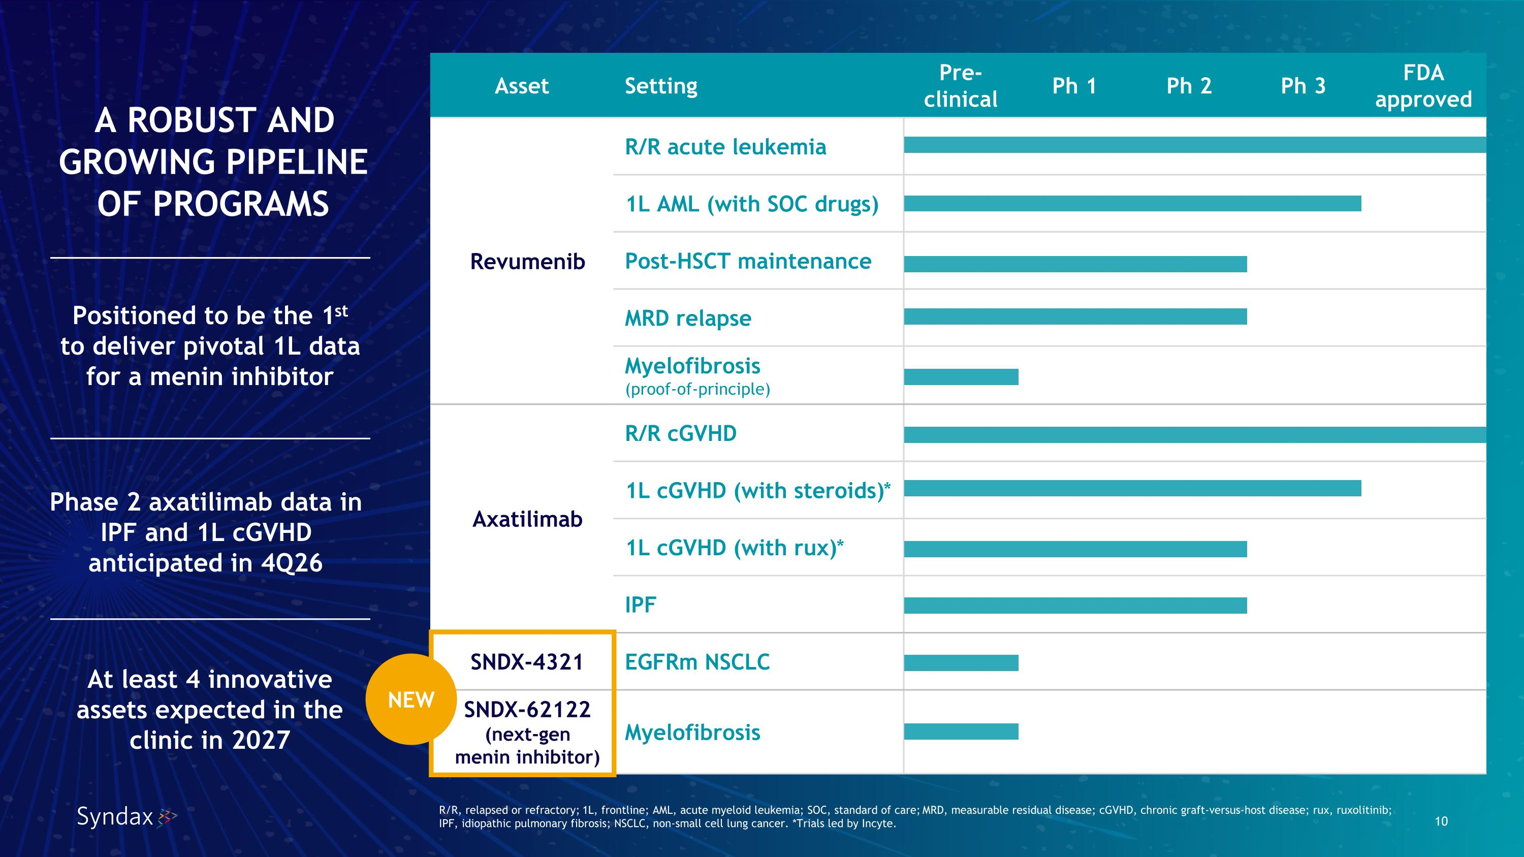
R/R, relapsed or refractory; 1L, frontline; AML, acute myeloid leukemia; SOC, standard of care; MRD, measurable residual disease; cGVHD, chronic graft-versus-host disease; rux, ruxolitinib;?IPF, idiopathic pulmonary fibrosis; NSCLC, non-small cell lung cancer. *Trials led by Incyte. Asset Setting Pre-clinical Ph 1 Ph 2 Ph 3 FDA approved Revumenib R/R acute leukemia 1L AML (with SOC drugs) Post-HSCT maintenance MRD relapse Myelofibrosis ?(proof-of-principle) Axatilimab R/R cGVHD 1L cGVHD (with steroids)* 1L cGVHD (with rux)* IPF SNDX-4321 EGFRm NSCLC SNDX-62122 ?(next-gen ?menin inhibitor) Myelofibrosis A ROBUST AND GROWING PIPELINE?OF PROGRAMS At least 4 innovative assets expected in the clinic in 2027 NEW Positioned to be the 1st?to deliver pivotal 1L data for a menin inhibitor Phase 2 axatilimab data in IPF and 1L cGVHD anticipated in 4Q26

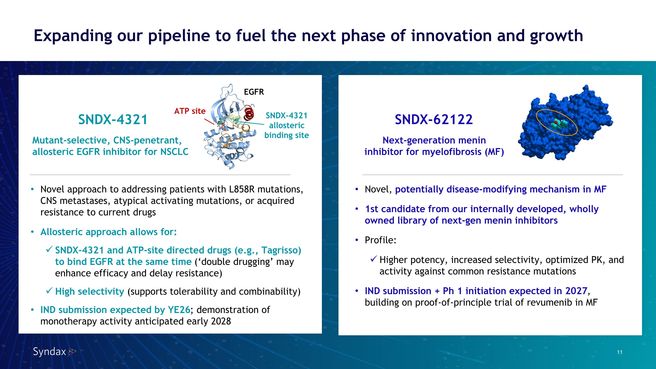
Expanding our pipeline to fuel the next phase of innovation and growth SNDX-4321 Next-generation menin inhibitor for myelofibrosis (MF) SNDX-62122 Novel, potentially disease-modifying mechanism in MF 1st candidate from our internally developed, wholly owned library of next-gen menin inhibitors Profile: Higher potency, increased selectivity, optimized PK, and activity against common resistance mutations IND submission + Ph 1 initiation expected in 2027, building on proof-of-principle trial of revumenib in MF SNDX-4321 allosteric binding site ATP site EGFR Mutant-selective, CNS-penetrant, allosteric EGFR inhibitor for NSCLC Novel approach to addressing patients with L858R mutations, CNS metastases, atypical activating mutations, or acquired resistance to current drugs Allosteric approach allows for: SNDX-4321 and ATP-site directed drugs (e.g., Tagrisso) ?to bind EGFR at the same time (‘double drugging’ may enhance efficacy and delay resistance) High selectivity (supports tolerability and combinability) IND submission expected by YE26; demonstration of monotherapy activity anticipated early 2028

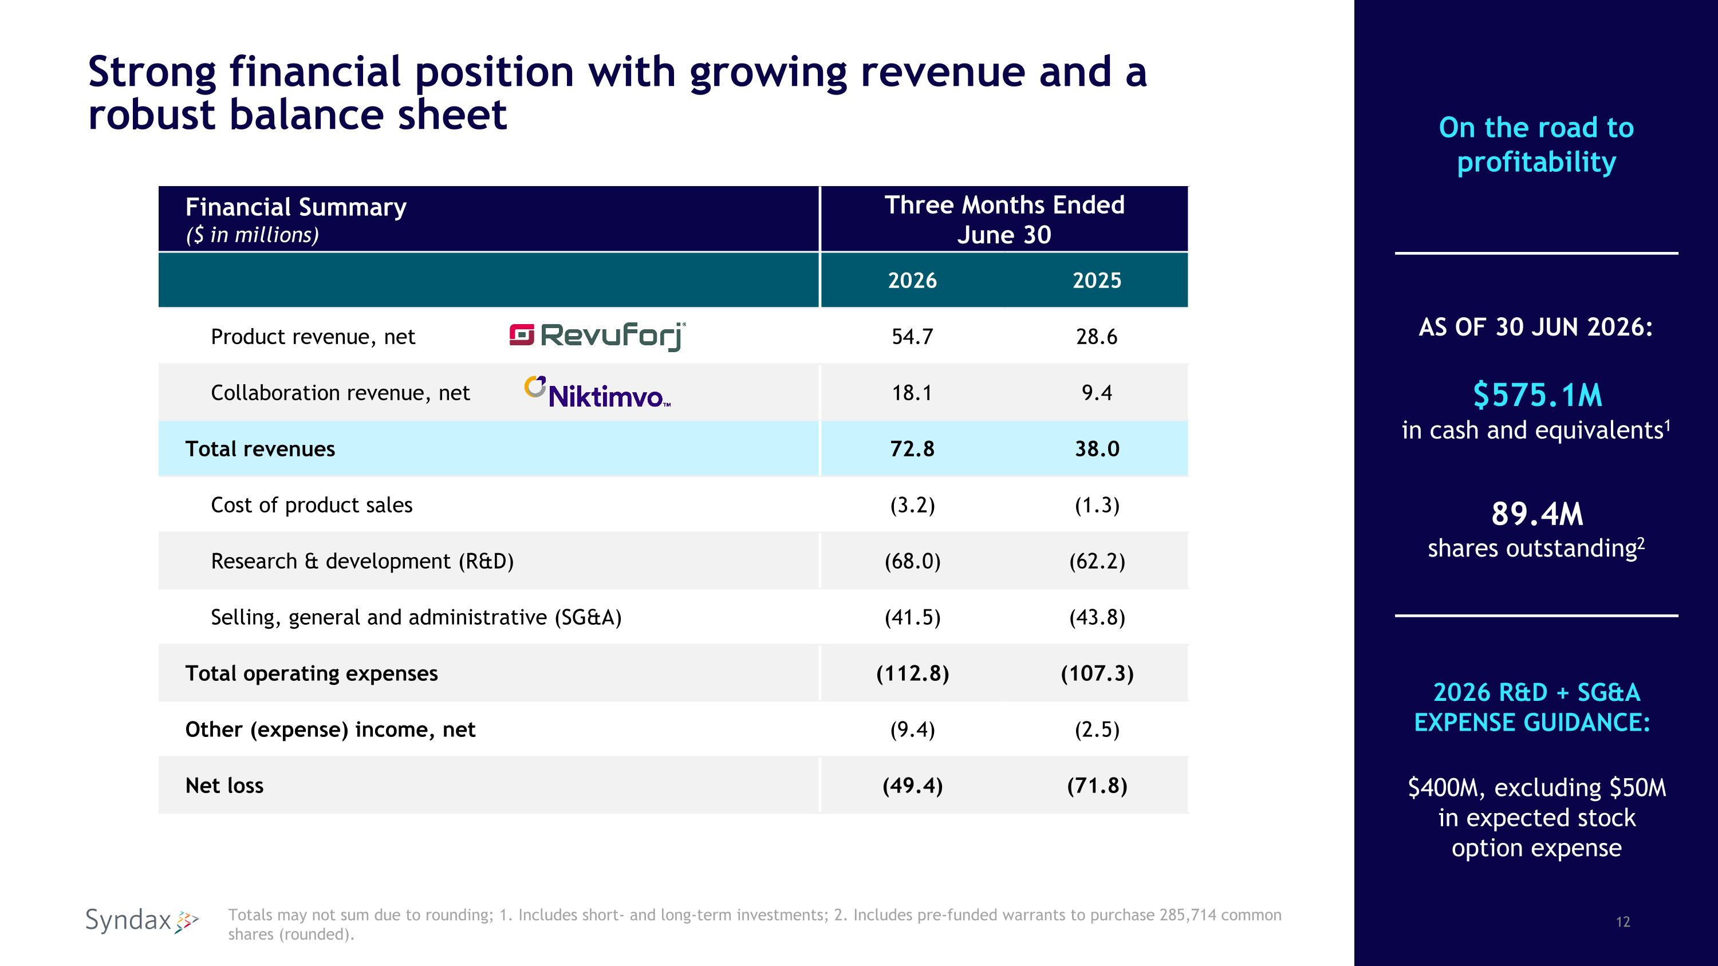
Strong financial position with growing revenue and a ?robust balance sheet Financial Summary ($ in millions) Three Months Ended?June 30 2026 2025 Product revenue, net 54.7 28.6 Collaboration revenue, net 18.1 9.4 Total revenues 72.8 38.0 Cost of product sales (3.2) (1.3) Research & development (R&D) (68.0) (62.2) Selling, general and administrative (SG&A) (41.5) (43.8) Total operating expenses (112.8) (107.3) Other (expense) income, net (9.4) (2.5) Net loss (49.4) (71.8) Totals may not sum due to rounding; 1. Includes short- and long-term investments; 2. Includes pre-funded warrants to purchase 285,714 common shares (rounded). AS OF 30 JUN 2026: $575.1M ?in cash and equivalents1 89.4M?shares outstanding2 2026 R&D + SG&A EXPENSE GUIDANCE: $400M, excluding $50M in expected stock option expense On the road to profitability

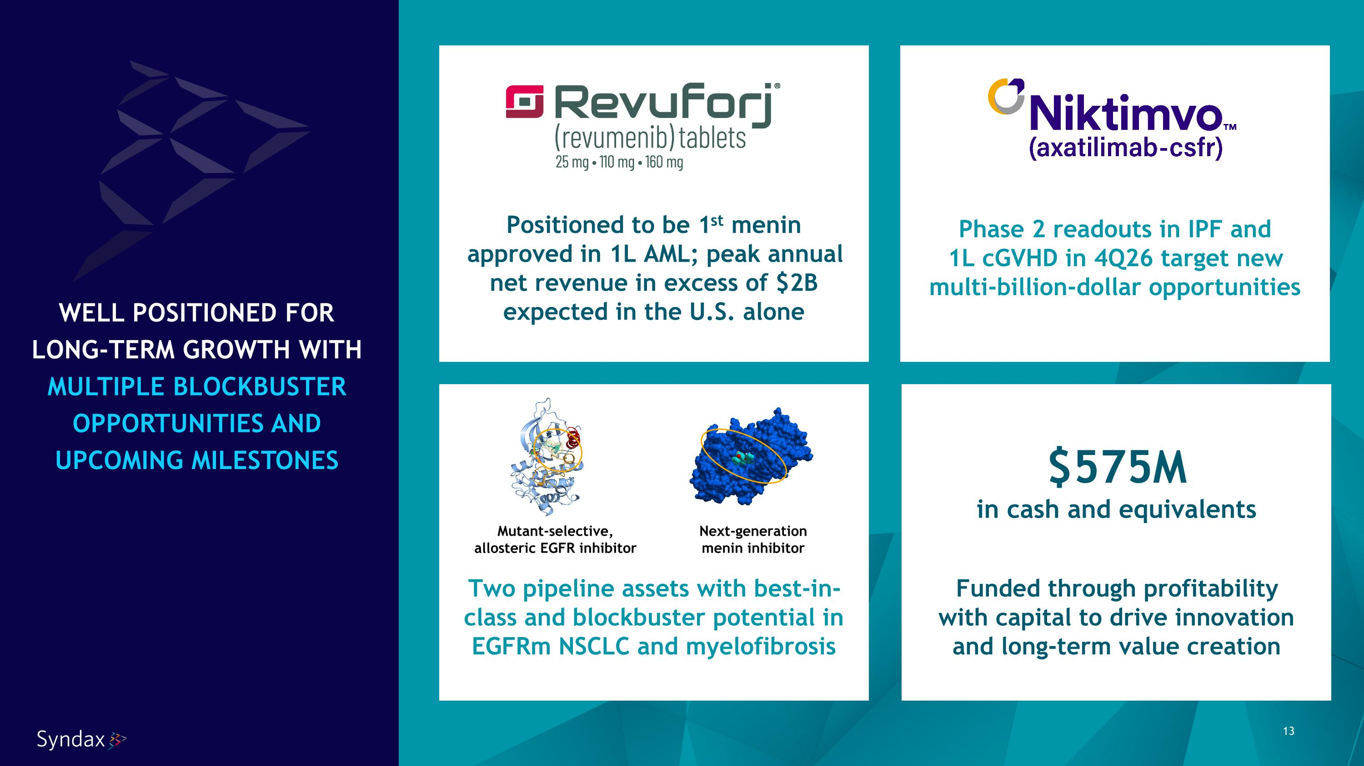
Phase 2 readouts in IPF and?1L cGVHD in 4Q26 target new multi-billion-dollar opportunities Positioned to be 1st menin approved in 1L AML; peak annual net revenue in excess of $2B expected in the U.S. alone Two pipeline assets with best-in-class and blockbuster potential in EGFRm NSCLC and myelofibrosis Funded through profitability?with capital to drive innovation and long-term value creation $575M in cash and equivalents Next-generation?menin inhibitor Mutant-selective, allosteric EGFR inhibitor WELL POSITIONED FOR LONG-TERM GROWTH WITH MULTIPLE BLOCKBUSTER OPPORTUNITIES AND UPCOMING MILESTONES

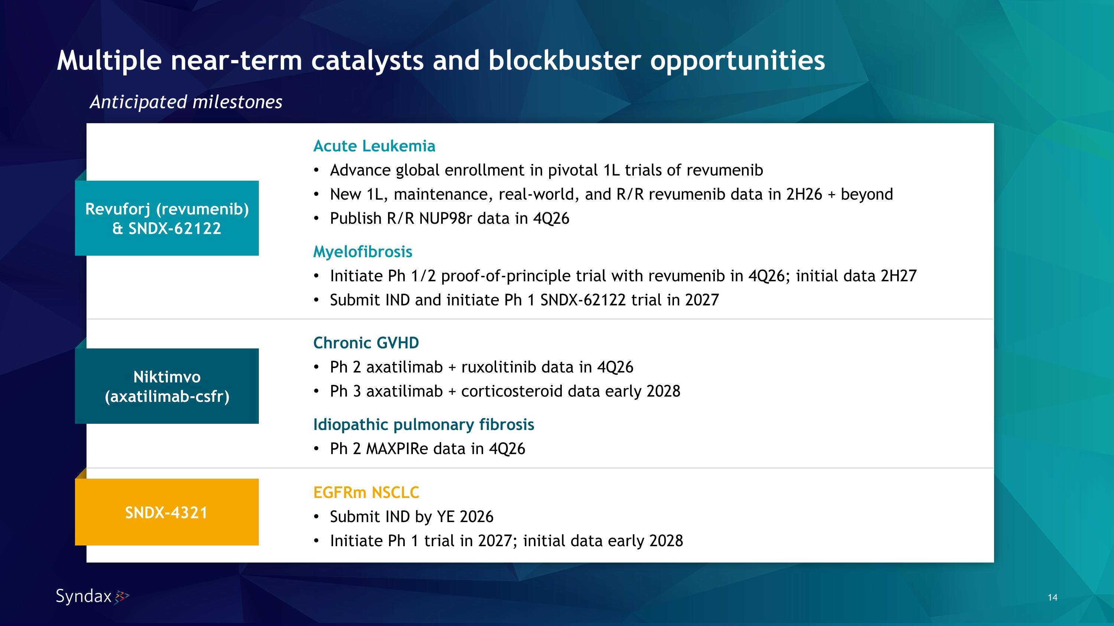
Acute Leukemia Advance global enrollment in pivotal 1L trials of revumenib New 1L, maintenance, real-world, and R/R revumenib data in 2H26 + beyond Publish R/R NUP98r data in 4Q26 Myelofibrosis Initiate Ph 1/2 proof-of-principle trial with revumenib in 4Q26; initial data 2H27 Submit IND and initiate Ph 1 SNDX-62122 trial in 2027 Chronic GVHD Ph 2 axatilimab + ruxolitinib data in 4Q26 Ph 3 axatilimab + corticosteroid data early 2028 Idiopathic pulmonary fibrosis Ph 2 MAXPIRe data in 4Q26 EGFRm NSCLC Submit IND by YE 2026 Initiate Ph 1 trial in 2027; initial data early 2028 Anticipated milestones Revuforj (revumenib)?& SNDX-62122 SNDX-4321 Niktimvo?(axatilimab-csfr) Multiple near-term catalysts and blockbuster opportunities


Sarah, diagnosed with R/R acute leukemia FUELED BY A PASSION FOR PATIENTS



